**Final Project Design Report**

Bluetooth Controlled Mario Kart Robot

MTE 100/GENE 121

Group 5

Nov 6, 2014

Prepared by

Yongxuan Li 20570064

Michael Ru 20566994

Kevin Huo 20571498

Sachin Apiah 20560433

Introduction

LEGO NXT is a popular platform for both teaching the basics of robotics as well as learning more about robotic design and development. Due to the modularity of LEGO, objects of almost any shape or size can be created using blocks and thus provide a good basis for a mechanical design. Additionally, using the NXT brick allows the programming of the mechanical parts to achieve many different tasks. Using these pieces, a fully functional mechatronics system can be created and utilized to solve a problem.

Design Problem Definition

There are many people who play the popular video game Mario Kart and other racing type games on video game consoles, but real life examples of this are uncommon. Even though there are many RC (remote controlled) cars available, they do not provide the full experience of a video game like Mario Kart (i.e. do not give power ups, cannot shoot others with balls). More so, the number of LEGO robots which provide a racing game experience is even less. Additionally, previous LEGO project examples lack systems which provide a realistic full game experience. Therefore, a problem that needs to be solved is the lack of real world *Mario Kart*-esque experiences which provide entertainment.

Goals and Objectives

The aim of this project is to provide an entertaining and interactive, real-life experience that resembles the mechanics and race-like quality of the video game *Mario Kart*. The final product should satisfy the user as a fun game that incorporates intricate coding and aesthetically pleasing hardware, as well as a suitable racecourse for the user to follow. The basis of this project is to use Bluetooth communication with a Wii remote to control the movements of the car.

Constraints

The constraints involved with the actual robot include that the robot must use one or two touch sensors, one colour sensor, motor encoders, and must use a Wii remote for movement commands. The movement of the robot must correspond to the inputs provided by the user through the Wii remote. It must turn left when remote is tilted to the left (and vice versa), drive forward when forward button is pressed, backwards when backward button is pressed, etc. It must also move in a fluent manner and not jitter when moving forward, turning, reversing or performing any other form of motor movement. Additionally, the robot must complete actions according to its environment/ input of sensor. For example, the touch sensor input causes the moving “kart” to become stunned for a couple seconds, and the colour sensor input makes the vehicle gain power ups or slowdowns. It must also be able to withstand multiple bumps and run-throughs without mechanical failure and the robot must be mechanically different than the standard configuration of the robot.

Additional constraints that have to do with the project include that the robot and program must provide an exceptional Mario-Kart/ video game like experience to the “players”. For example, it must include sound effects for different actions and require players to input their information. The player must interact with the robot, either directly or indirectly. For example, the robot should prompt for user input and allow the user to select different game modes and characters.

Criteria

The robot vehicle should be visually appealing to the user and gameplay should be consistent (ie. inputs do not produce undesirable results). The robot should also be easily built and maintained, and it should also not require too much additional resources to build.  Another criteria should be that this robot should be capable of using as many sensors and data as possible. This would allow for more functionality and expanded possibilities for the software. Additionally, any user should be able to easily interact with and understand the robot and game.

Mechanical Designs

Design One Evaluation see Figure 1.1

This design matches most of the given constraints but uses three bump sensors which is greater than the constraint of 2 bump sensors. However this constraint can be easily fixed by removing one of the bump sensors. This design also does not satisfy all criteria perfectly. Therefore a variant of this design with only two bump sensors should considered when creating the criteria decision matrix.

In terms of criteria, this design matches some of the criteria, but doesn’t fully match all of them. This design looks sort of visually appealing, more so than the standard configuration, but is harder to build due to the gears and various additional components needed. Therefore, this design is a good design but needs some changes to be able to be considered as a final design for this project.

Design Two Evaluation see Figure 1.2

This design matches all the given constraints but not all the criteria perfectly. Due to the availability to only a limited amount of sensor inputs, this design might not travel efficiently. For example, turns could be made with more precision for the usage of more precise sensors. The shooter on top could have a design change to act more efficient. The changes that could be made to it could be a certain degree rotation for the shooter in order to shoot at target without orienting the entire car.

A few pros for this design would be that it looks aesthetically good and has a shooting component. Also Mr. Mario looks fit and happy. Therefore this design mostly meets the satisfactory conditions but more changes to the design could be made in order to be more efficient.

Design Three Evaluation see Figure 1.3

The design follows all of the given constraints, but neglects some of the criteria. Incorporating the free spinning ball will be a challenge, as it might have a tendency to interfere with the other features, such as the location of the front touch sensor or the ball shooter. Even so, the fluidity will be rewarding if it is done well. While the rest of the robot should be easily built, the task of finding a proper ball that doesn’t negatively affect performance through either friction or mechanical inconsistency will be difficult. The visual appearance of the car can be improved, as its current design looks almost standard and slightly dull. The car does not maximize usage of sensors, as any extra sensors would cause the car to look bulky and slow. On the other hand, the visually appealing factor of the car will be the incorporation of the free spinning ball, which makes the car stand out as unique and interesting. Also, any user controlling the car should easily be able to manipulate the controls and car movement to his/her own satisfaction.

Design Four Evaluation see Figure 1.4

The robot shown in would be quite versatile in its movement as it would be a forward wheel drive vehicle, meaning it would be able to complete sharp turns as the wheels being steered are at the front of the robot. This makes the robot more responsive and allow it to have more fluid movement.

Also, having the sensors of the robot “kart” in strategic locations allows the robot to be more responsive towards the environment and racetrack. Having the two touch sensors on the two sides of the kart will maximize the chances of triggering the sensor when the vehicle collides with a wall during a turn.

However some cons to this design would not be very visually appealing as it looks very minimalistic (just a brick with two motors attached to it). Also the mechanical design is not very complicated thus it would be *too* easy to build. Furthermore, with the ball shooter in the front, the robot would not be very interactive to the other race kart on the track as it would not be able to shoot at the sides touch sensors to stun the other robot.

Decision Matrix

In order to decide on the design of the robot, a decision matrix is used. The four criteria that the designs are judged upon are:

Mobility: includes the turning capabilities of the car as well as the top speed

Ease of Build: How much resources are required to complete this design and how easy is it to build

Appeal: The attractiveness of the car and how well the design adds to the experience of the game

Additional Capabilities: Additional sensors incorporated into the design that might not get too much use during Demo Day but could potentially be useful for future software changes.

See Appendix 2 for additional tables

Task List

* Start communication of Wii remote and NXT robot with laptop over Bluetooth
* Prompt the user for several information inputs before the race begins.
* Keep track of timer and motor encoders to determine how fast the user completes the racetrack as well as the average speed of the robot over the course of the race.
* Read data sent from computer and translate into motor movement
* While in motion read in data from sensors (touch or colour) and translate that data into motion for the robot, (e.g. speed up, slow down or stop)
* Report in real time some information about the race (e.g. lap number, item get)
* After a specified number of laps, display information about the race including total time elapsed.

Project Planning

See appendix Figure 3.1 for Gantt Chart

Appendix

1 – Alternative Designs

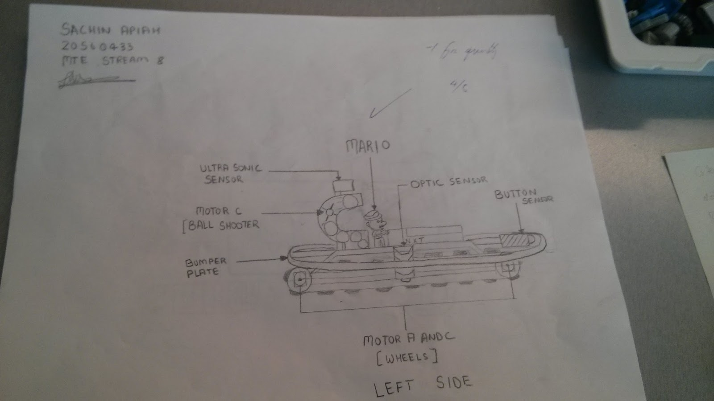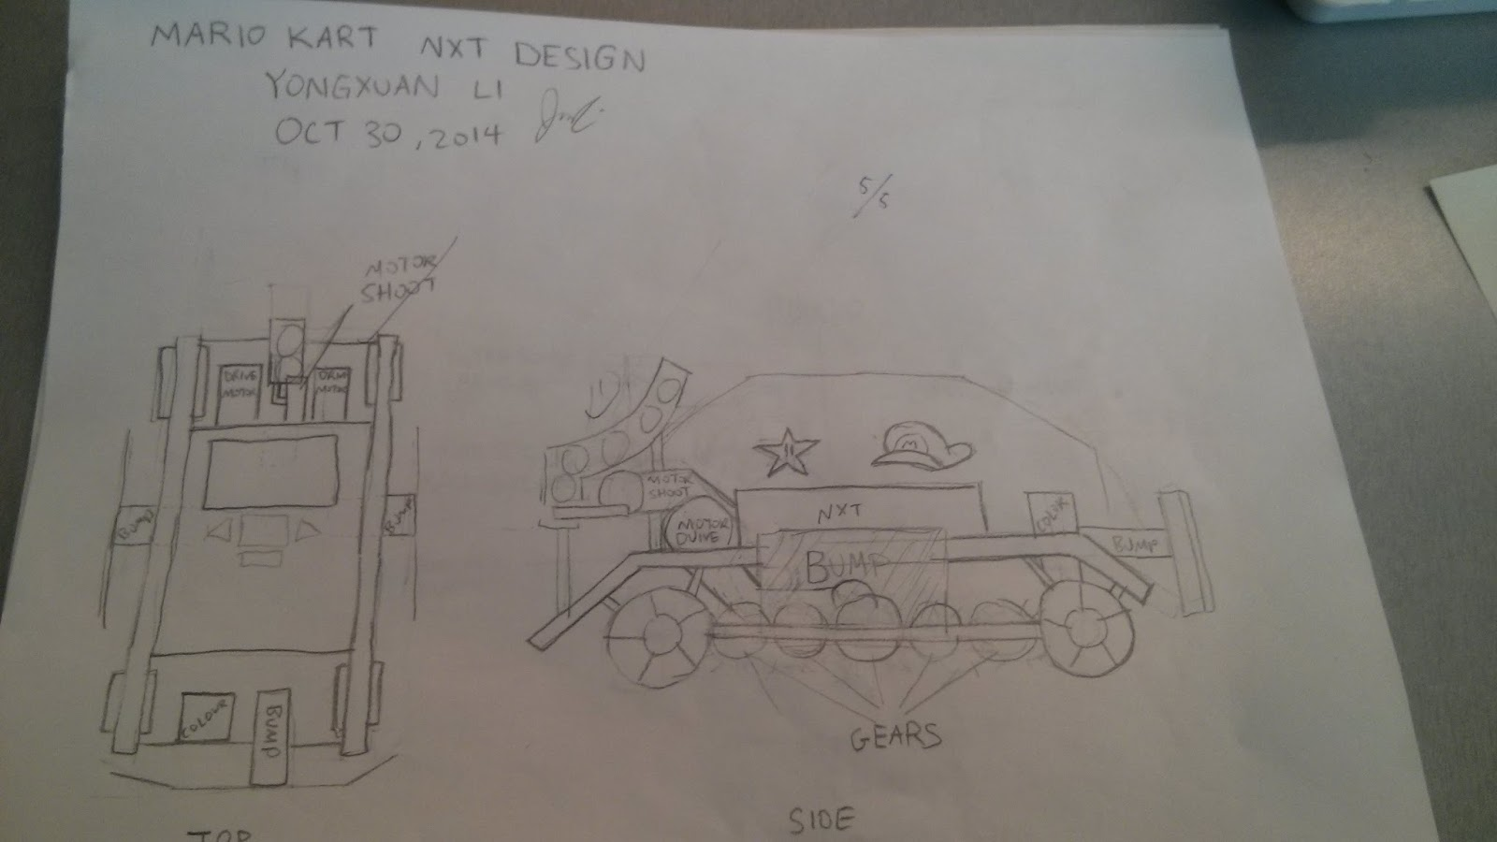

Figure 1.2

Figure 1.1

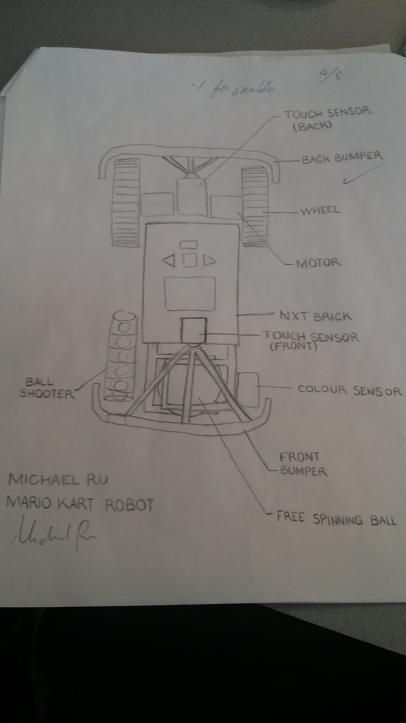

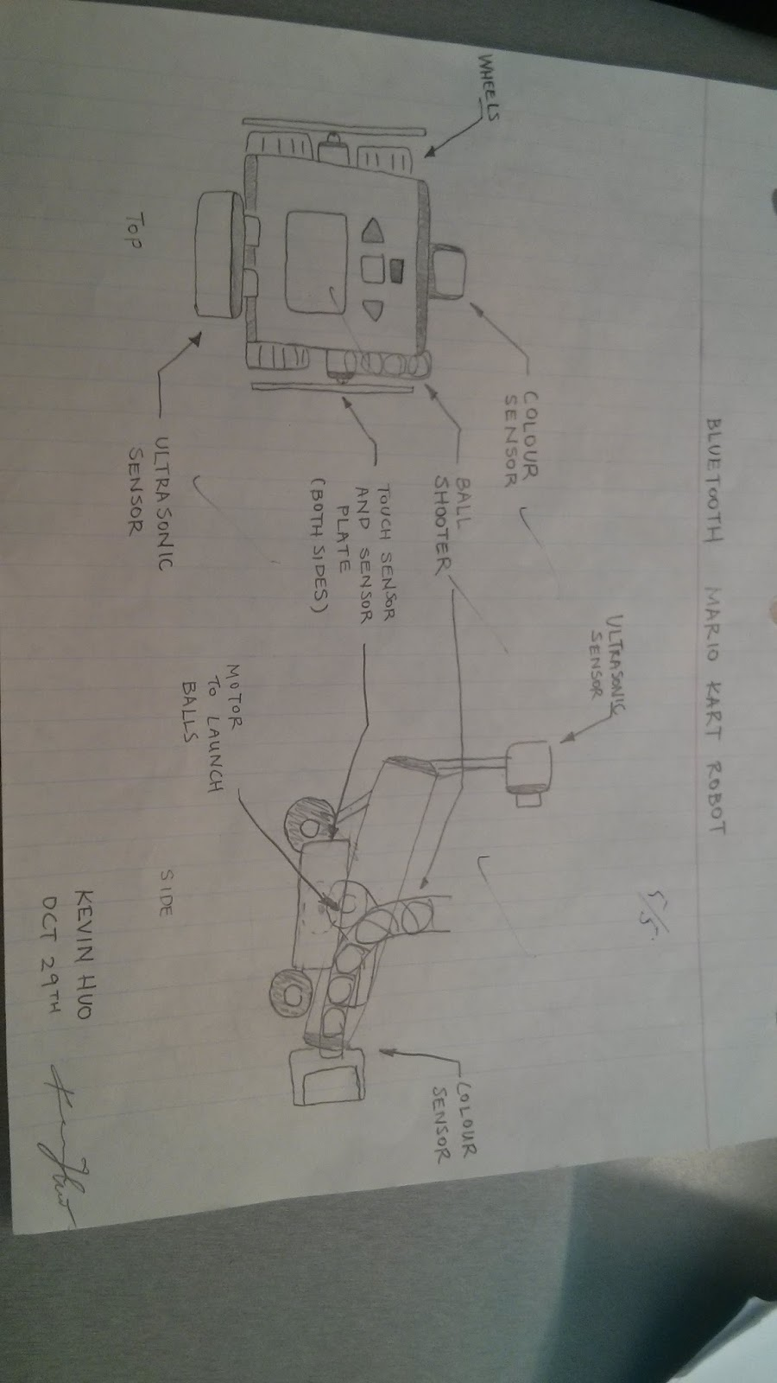

Figure 1.4

Figure 1.3

2 – Decision Matrix

|  |  |  |  |  |
| --- | --- | --- | --- | --- |
| Criterion | Design 1 | Design 2 | Design 3 | Design 4 |
| Mobility | 4 wheels connected by gears | 2 wheels + 2 free wheels (using caterpillar tracks) | 2 wheels + free spinning ball | 2 wheels + 2 free wheels |
| Ease of build | Medium hard | Medium Hard | Medium | Easy |
| Appeal | Good | Good | Acceptable | Non-appealing |
| Additional Capabilities | Acceptable | Good | Acceptable | Good |

Table 2.1 Tabulated Design Criteria

|  |  |  |  |  |
| --- | --- | --- | --- | --- |
| Criterion | Design 1 | Design 2 | Design 3 | Design 4 |
| Mobility | 0.6 | 0.5 | 0.8 | 0.5 |
| Ease of build | 0.4 | 0.4 | 0.5 | 0.8 |
| Appeal | 0.8 | 0.8 | 0.6 | 0.2 |
| Additional Capabilities | 0.4 | 0.6 | 0.4 | 0.6 |

Table 2.2 Mapped Ratings

Explanation of Ratings

Mobility: This is judged on how well the robot maneuvers, including turn capabilities and top speed. Design 3 scores the highest because the free spinning ball allows for tights turns off just the two motor controlled wheels. Design 1 scores a 0.6 because it cannot turn as well as 3 because all both wheels on the right are connected with the same motor but the top speed of this robot will be high. Finally design 2 and 4 both score 0.5 because they do not make turns as easily either and the two free wheels cause friction during turns.

Ease of build: This is judged on the resources required to build the robot, both human as well as financial. Design 4 is similar to the standard configuration and so has the highest rating. Design 1 and 2 are both quite a bit challenging due to the more complex components and so both rank 0.4. Design 3 is also quite easy to build but requires a free spinning ball which is not included in the LEGO kit.

Appeal: This is judged on how well the car looks and how probable a design similar to it would appear in the video game Mario Kart. Designs 1 and 2 are both quite cool looking while design 3 is simpler and thus less appealing. Design 4 is very similar to the standard configuration and thus has almost no appeal since it doesn’t add on anything to differentiate itself from other designs.

Additional Capabilities: This is judged on how many additional components are added onto the design based off the required components listed in the constraints. Designs 1 and 3 both contain an additional bumper sensor and thus score 0.4 while design 2 and 4 include, in addition to the bump, an ultrasonic sensor. Even though this sensor might not get used during Demo day, adding it to the design allows for more options later in the life of the robot, if it exists.

|  |  |  |  |  |  |  |
| --- | --- | --- | --- | --- | --- | --- |
| Criterion | Mobility | Ease of Build | Appeal | Additional Capabilities | Row Total | Normal Rating |
| Mobility |  | 1 | 1 | 1 | 3 | 0.5 |
| Ease of Build | 0 | - | 0 | 1 | 1 | 0.166 |
| Appeal | 0 | 1 | - | 1 | 2 | 0.333 |
| Additional Capabilities | 0 | 0 | 0 | - | 0 | 0 |

Table 2.3 Relative Importance of Criteria

Use a scale of 0.2 – 1.0 to give some importance to the lowest rating criteria

0 0.2 0.467 0.733 1.0

|  |  |  |
| --- | --- | --- |
| Criterion | Relative Rating | Fractional Rating |
| Mobility | 1.0 | 1.0 / 2.4 = 0.4167 |
| Ease of Build | 0.467 | 0.467 / 2.4 = 0.1946 |
| Appeal | 0.733 | 0.733 / 2.4 = 0.3054 |
| Additional Capabilities | 0.2 | 0.2 / 2.4 = 0.0833 |
|  | Total Rating: 2.4 |  |

Table 2.4 Scaled Ratings of Criteria

2.5 Calculating Design Ratings

Design 1: (0.6)(0.4167) + (0.4)(0.1946) + (0.8)(0.3054) + (0.4)(0.083) = 0.6055

Design 2: (0.5)(0.4167) + (0.4)(0.1946) + (0.8)(0.3054) + (0.6)(0.083) = 0.58

Design 3: (0.8)(0.4167) + (0.5)(0.1946) + (0.6)(0.3054) + (0.4)(0.083) = 0.647

Design 4: (0.5)(0.4167) + (0.8)(0.1946) + (0.2)(0.3054) + (0.6)(0.083) = 0.475

Therefore from these calculations, Design 3 is the one that matches these criteria the best.

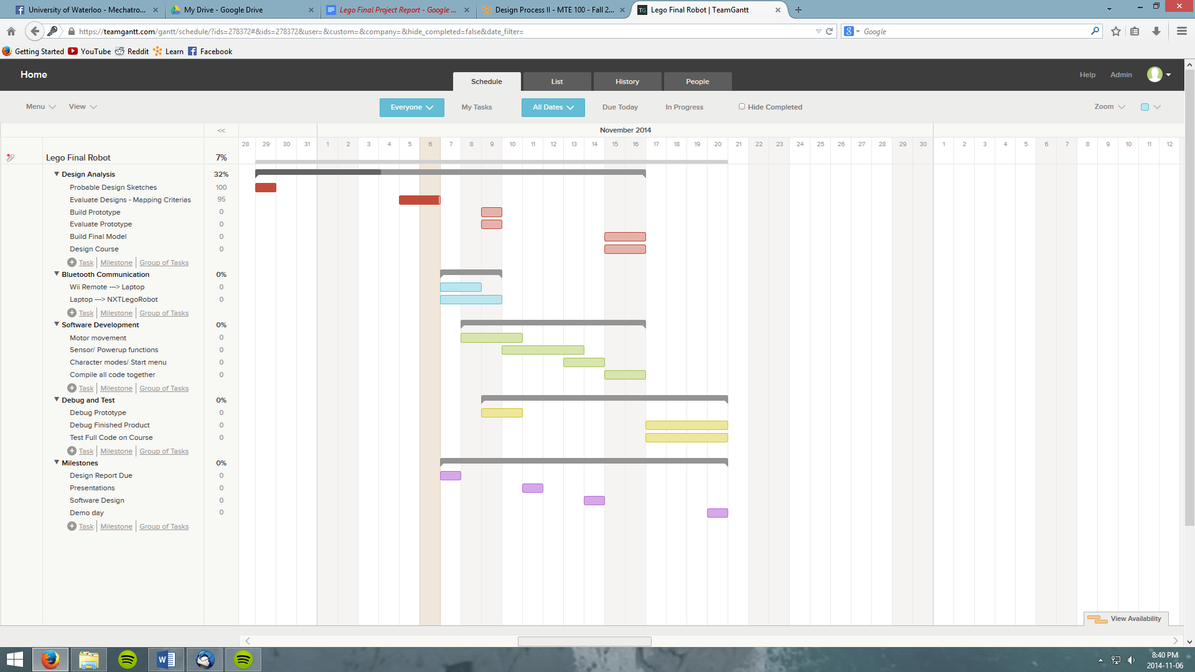3 – Gantt Chart

Figure 3.1 Project Plan